OS Lab 9

11762 Muhammad Kashif

Task 1

#include <stdio.h>

#include<unistd.h>

int main(){

int pipe1[2], pipe2[2];

int returnstatus1, returnstatus2;

int pid;

int pipe1writemessage;

int pipe2writemessage;

int readmessage;

int val;

int sum =0;

returnstatus1 = pipe(pipe1);

if(returnstatus1 == -1){

printf("Unable to create pipe1");

return 1;}

returnstatus2 = pipe(pipe2);

if(returnstatus2 == -1){

printf("Unable to create pipe2");

return 1;}

pid = fork();

if(pid != 0){

close(pipe1[0]);

close(pipe2[1]);

printf("Enter the The Number :");

scanf("\n%d",&pipe1writemessage);

for(int i=0;i<3;i++){

val =pipe1writemessage %10;

write(pipe1[1], &val, sizeof(val));

pipe1writemessage=pipe1writemessage/10;

printf("\nIn parent writing to pipe 1 - message is %d\n", val);

sleep(1);}

read(pipe2[0], &readmessage, sizeof(readmessage));

printf("\nIn parent reading from pipe 2 - message is 'sum is %d\n", readmessage);}

else{

close(pipe1[1]);

close(pipe2[0]);

for(int i=0;i<3;i++){

read(pipe1[0], &readmessage, sizeof(pipe1writemessage));

printf("\nIn child reading from pipe 1 - message is %d\n", readmessage);

sum = sum+ readmessage;

sleep(1);}

write(pipe2[1], &sum, sizeof(sum));

pipe2writemessage=sum;

write(pipe2[1], &val, sizeof(pipe2writemessage));

printf("\n\nIn child sum of numbers is %d", sum);}

return 0;}#include <stdio.h>

#include<unistd.h>

int main(){

int pipe1[2], pipe2[2];

int returnstatus1, returnstatus2;

int pid;

int pipe1writemessage;

int pipe2writemessage;

int readmessage;

int val;

int sum =0;

returnstatus1 = pipe(pipe1);

if(returnstatus1 == -1){

printf("Unable to create pipe1");

return 1;}

returnstatus2 = pipe(pipe2);

if(returnstatus2 == -1){

printf("Unable to create pipe2");

return 1;}

pid = fork();

if(pid != 0){

close(pipe1[0]);

close(pipe2[1]);

printf("Enter the The Number :");

scanf("\n%d",&pipe1writemessage);

for(int i=0;i<3;i++){

val =pipe1writemessage %10;

write(pipe1[1], &val, sizeof(val));

pipe1writemessage=pipe1writemessage/10;

printf("\nIn parent writing to pipe 1 - message is %d\n", val);

sleep(1);}

read(pipe2[0], &readmessage, sizeof(readmessage));

printf("\nIn parent reading from pipe 2 - message is 'sum is %d\n", readmessage);}

else{

close(pipe1[1]);

close(pipe2[0]);

for(int i=0;i<3;i++){

read(pipe1[0], &readmessage, sizeof(pipe1writemessage));

printf("\nIn child reading from pipe 1 - message is %d\n", readmessage);

sum = sum+ readmessage;

sleep(1);}

write(pipe2[1], &sum, sizeof(sum));

pipe2writemessage=sum;

write(pipe2[1], &val, sizeof(pipe2writemessage));

printf("\n\nIn child sum of numbers is %d", sum);}

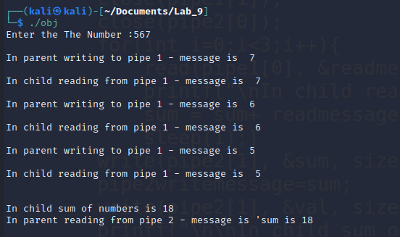 return 0;}

Output